- To compare the foaming capacity of different samples of soap.
Theory:
Soap is an anionic surfactant used in conjunction with water for cleaning and washing. It is usually available in solid bars or as a viscous liquid. Soap comprises sodium or potassium salts of fatty acids via saponification, which is the reaction of ordinary oils or fats with strong alkaline. The base hydrolyzes the lipids, resulting in alkali fatty acid salts (crude soap) and glycerol. Soap molecules feature a hydrophilic end that dissolves in water and a hydrophobic end that dissolves non-polar grease molecules, making them excellent for cleaning.By measuring the amount of foam created by an equivalent amount of various soap samples, the foaming ability of different soap samples can be compared.
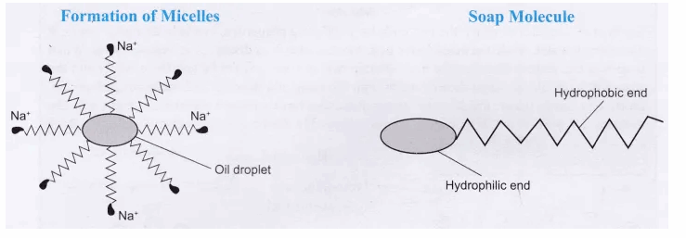
Commercial Soap
Commercial production of soap The most popular soap making process today is the cold process method, where fats such as olive oil react with alkaline solid solution, while some soapers use the historical hot process. Handmade soap differs from industrial soap in that. Usually, an excess of fat is sometimes used to consume the alkali (superfatting). The glycerin is not removed, leaving a naturally moisturizing soap and not pure detergent. Often, emollients such as jojoba oil or Shea butter are added 'at trace' . Most of the oils have saponified so that they remain unreacted in the finished soap.
Fat in soap
Soap is derived from either vegetable or animal fats. Sodium Tallowate, a common ingredient in much soap, is derived from rendered beef fat. Soap can also be made of vegetable oils, such as palm oil, and the product is typically softer. An array of saponifiable oils and fats are used in the process such as olive, coconut, palm, cocoa butter to provide different qualities. For example, olive oil provides mildness in soap; coconut oil provides lots of lather; while coconut and palm oils provide hardness. Sometimes castor oil can also be used as an ebullient. Smaller amounts of unsaponifable oils and fats that do not yield soap are sometimes added for further benefits. Preparation of soap In cold-process and hot-process soap making, heat may be required for saponification. Cold-process soap making takes place at a sufficient temperature to ensure the liquification of the fat being used. Unlike cold-processed soap, hot-processed soap can be used right away because the alkali and fat saponify more quickly at the higher temperatures used in hot-process soap making. Hot-process soap making was used when the purity of alkali was unreliable. Cold-process soap making requires exact measurements of alkali and fat amounts and computing their ratio, using saponification charts to ensure that the finished product is mild and skin-friendly.
Hot process
In the hot-process method, alkali and fat are boiled together at 80–100 °C until saponification occurs, which the soap maker can determine by taste or by eye. After saponification has occurred, the soap is sometimes precipitated from the solution by adding salt, and the excess liquid drained off. The hot, soft soap is then spooned into a mold.
Cold process
A cold-process soap maker first looks up the saponification value of the fats being used on a saponification chart, which is then used to calculate the appropriate amount of alkali. Excess unreacted alkali in the soap will result in a very high pH and can burn or irritate skin. Not enough alkali and the soap are greasy. The alkali is dissolved in water. Then oils are heated, or melted if they are solid at room temperature. Once both substances have cooled to approximately 100-110°F (37-43°C), and are no more than 10°F (~5.5°C) apart, they may be combined. This alkali-fat mixture is stirred until "trace". There are varying levels of trace. After much stirring, the mixture turns to the consistency of a thin pudding. "Trace" corresponds roughly to viscosity. Essential and fragrance oils are added at light trace

Source: https://www.icbse.com
Experimental Procedure
- Four different samples of soaps, distilled water, electronic balance, four test tubes, four beakers (100 mL), four glass rods, a measuring cylinder and a measuring scale (15cm) and a cutter knife.
- Take four labelled 100 mL beakers.
- Take beaker A.
- Put the A beaker on the electronic weighing balance and the weighing balance shows the weight of the empty beaker
- Use the TARE button to show a reading (0.00g) and add soap A into the beaker by making it a small piece using a cutter knife until the electronic balance shows a 1g reading. And repeat the steps for B, C, and D
- Add 20 mL of distilled water to all the soap samples using a measuring cylinder from the beaker containing distilled water. Dissolve the soap in water by stirring the mixture with a glass rod.
- Take a test tube stand, place the four test tubes, and label them as tubes A, B, C, and D. Pour 1 mL each of the above-prepared soap solutions using a measuring cylinder in the corresponding test tubes.
- Add 5 mL of distilled water from the 250ml beaker to each test tube using a measuring cylinder.
- Take the test tube labelled test tube A and shake it ten times by placing the thumb on its mouth. (Fig 3)

- By shaking the test tube will form the foam. Using a measuring scale, measure the length of the foam produced.
- Repeat the steps with the remaining three samples of soap solutions.

- Note: When soap reacts with hard water, it forms a scum by responding with the salts of magnesium and calcium ions. This scum is insoluble and floats on the surface of the water. Calcium and magnesium ions in hard water produce curdy white precipitates of calcium and magnesium salts of fatty acids. The presence of calcium and magnesium salts in water precipitates the soap, reducing its cleansing power and, hence, foaming capacity.

Experimental Outcome:
Infer from the observations that which soap sample produces the maximum
length of foam (lather) in test tube.

